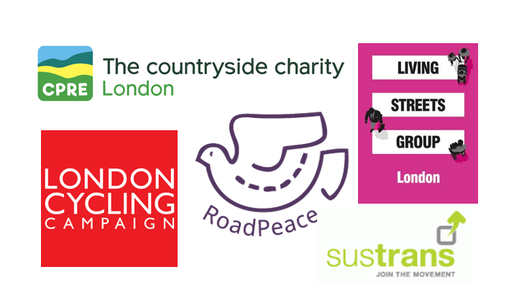
London Boroughs Healthy Streets Scorecard Coalition

The London Boroughs Healthy Streets Scorecard Coalition is seeking a Campaign Promotions Officer to support an exciting new campaign which aims to change transport for the better across all of London.

Job Summary - Campaign Promotions Officer – London Boroughs Healthy Streets Scorecard

We are seeking a Campaign Promotions Officer for this exciting project. The role is offered on a freelance basis initially for 6 months, in the run up to the launch of the second annual Healthy Streets Scorecard scheduled for July 2020. The successful applicant will be required to:
- Work with coalition partners to create a website where people can explore the Scorecard data as well as related content and reports
- help manage project communications, in particular (a) develop a social media presence alongside partners and (b) support contact with London Boroughs.

The role is offered on a freelance basis 8 hours a week at £20 per hour.
- We are open to requests for flexible working and will consider alternative patterns of work such as term-time only or hours worked over a number of days.
- The role can be based either at CPRE London offices in Cowcross Street London EC1M 6EJ or as a freelancer in your own place of work.

The campaign

A huge opportunity to improve London’s health through improving transport
Transport and health are inextricably linked in two ways.
- Journeys by walking and cycling, or ‘active travel’, or by public transport where it involves an element of active travel, have well-documented health benefits.
- Air quality is poorer where the share of journeys being made by car is higher, because of increased air pollution, and road danger is also increased.

For our health, London desperately needs to increase the number of trips being taken by public transport, walking or cycling. But road danger, air and noise pollution and unattractive car-dominant environments continue to act as a deterrent to walking and cycling in London.

London boroughs are key to delivering change but there is low take-up in many boroughs of the most important measures which are needed, for example introducing modal filters, controlled parking, 20mph speed limits and protected cycle tracks. There can be public resistance to change and boroughs struggle to gain buy-in from residents. Funding is also a barrier, though many of the measures needed are in fact relatively low-cost.

London Living Streets, London Cycling Campaign, RoadPeace, CPRE London and Sustrans, who all bring a strong track record in advocating sustainable and active travel, have therefore come together to launch a Healthy Streets Scorecard to help London boroughs make the case for, and implement, key healthy streets measures.

Campaign aims
- Prompt local authorities to engage in faster/better action on key input measures
- Enable councils, residents and campaign groups to link inputs with outcomes on active travel and identify areas of weakness/slow progress
- Improve the recognition and knowledge, among key audiences and the public, of the measures councils can take, and should be taking, to increase active travel rates and improve air quality and road safety while also reducing congestion on the roads
- Gain public, professional and political support for the input measures we are promoting

Person specification

- Able to run a successful and professional social media account
- Experience of writing and editing content for use across all communication channels
- Experience of using data to tell a story
- Experience of creating and writing newsletters, fliers and posters using graphics and imagery is desirable
- Experience of managing / updating web content
- Experience of managing website development projects
- A strong commitment to the project objectives
- Experience of campaigning / influencing or an interest in campaigning and/or politics
- Entitled to work in the UK

Please apply in writing to Alice Roberts at CPRE London alice@cprelondon.org.uk with a covering letter and CV by midday Tuesday 28 January 2020

Closing date for applications midday Tuesday 28 January 2020

