For immediate release

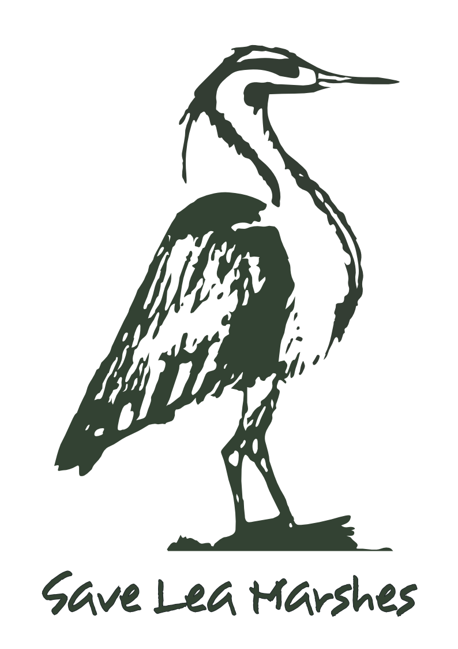

Campaigners reveal vision for wild swimming
in Waltham Forest

Save Lea Marshes [1] and CPRE London [2] have joined forces to campaign to transform the historic filter beds on Lea Bridge Road [3], once used by Thames Water [4], into a place for wild swimming.

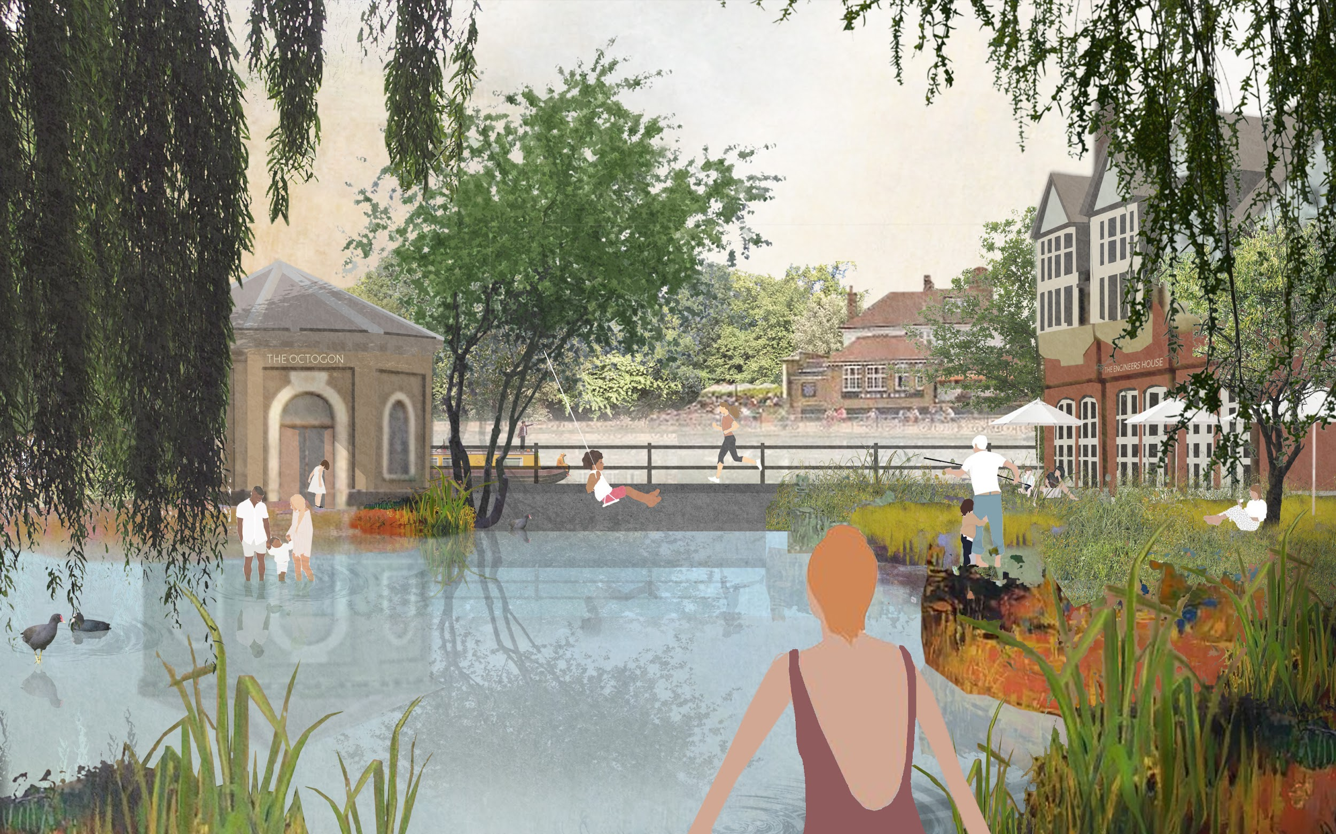

Campaigner Harry Hewat said, ‘I’ve always been shocked by how dislocated this landscape is, with so many barriers and fences that detract from the natural beauty of the area and the ability to roam. This site is the missing piece of the jigsaw. Opening it up will stitch together Leyton and Walthamstow Marshes to the north, the Waterworks Centre Nature Reserve to the east, Hackney Marshes and Middlesex Filter Beds to the south and the river and towpath to the west to create a huge urban park. We’re calling it the East London Waterworks Park!’

Abigail Woodman of Save Lea Marshes said, ‘We want people to sign our petition [5]. The site is Metropolitan Open Land and should be returned to the people of East London as a place for wild swimming and a place where people learn to live harmoniously with nature through small-scale food growing or sustainable foraging. It should be rewilded, with the built environment reclaimed by nature in some places and landscaping and planting in others.’

Peter Mudge, a local resident, said, ‘Retaining and enhancing the site’s historic structures, including the unusual octagonal sluice building, gives us an opportunity to showcase the area’s industrial heritage.’

Campaigner and architect/landscape architect Kirsty Badenoch said, ‘In our time of environmental crisis, chances to protect and reclaim areas of inner-city Metropolitan Open Land have never been more important. This currently under-utilised site has a strategic position within the Lea Valley Regional Park and this is a rare opportunity to reconnect the wider ecologies and provide valuable community green space.’

Alice Roberts of CPRE London said, ‘The site is currently owned by the Education and Skills Funding Agency (ESFA) and is within the Lee Valley Regional Park, and we call on Waltham Forest Council to work with the ESFA and the Lee Valley Regional Park Authority to take full advantage of this once-in-a-lifetime opportunity to create a unique park uniting Waltham Forest and Hackney.’

ENDS

For more information, contact Abigail Woodman of Save Lea Marshes on 07870 417056 or Alice Roberts of CPRE London on 0779 294 2691.

Notes to Editors
[1] Save Lea Marshes (SLM) campaigns to keep the marshes of the lower Lea Valley – Hackney Marshes, Leyton Marsh and Walthamstow Marsh – open, green and free from development. Working cooperatively with other local and special-interest groups, it seeks to preserve the land for nature and open community use. For more information see www.saveleamarshes.org.uk.
[2] CPRE London is the London branch of The Countryside Charity (formerly the Campaign to Protect Rural England). It is a membership-based charity with 2,500 members across London, campaigning to save London’s protected green spaces and parks and to make London a better place for everyone. For more information see www.cprelondon.org.uk.

[3]
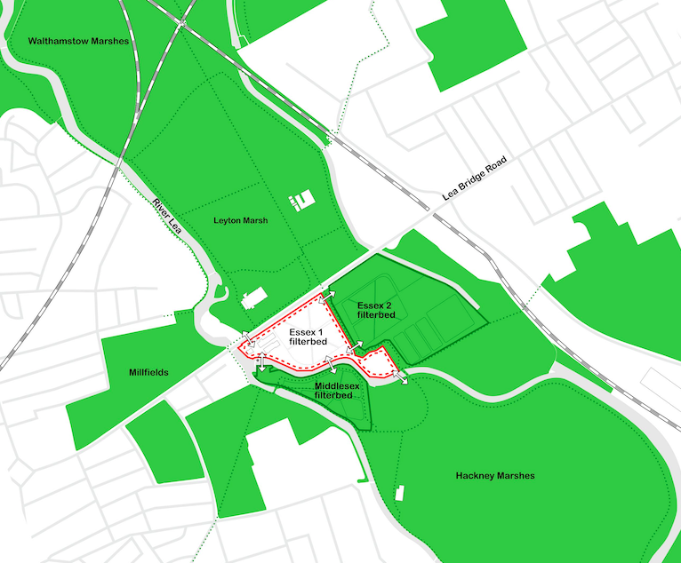
[4] See www.saveleamarshes.org.uk/east-london-waterworks-park for a brief history of the site.
[5] See https://www.change.org/p/waltham-forest-council-create-a-place-for-wild-swimming-in-waltham-forest-now or http://chng.it/94vzkWxqVm for the petition.

