MEDIA RELEASE
FOR IMMEDIATE RELEASE
Call Alice Roberts on 07792 942 691 or Neil Sinden 07496 805 354 for more information

Redbridge to allocate over three times more land than realistically needed for new housing, including an area of Green Belt the size of 180 football pitches

Green space campaigners today give evidence that demonstrates Redbridge Council’s plans to release Green Belt for housing are completely unnecessary

CPRE London [1] will today show the Planning Inspector [2] how Redbridge Council proposes to allocate over three times the amount of land needed for housing – including five large precious Green Belt sites. An area the size of 180 football pitches of protected green space will be lost if the Planning Inspector agrees Redbridge Council’s plans. [3]

Campaigner Alice Roberts will say: “Redbridge proposes a housing target of nearly 1,500 units per year for 13 years up to 2030. But nothing like that number has been built in Redbridge in recent times: last year 580 units were built in Redbridge and over the last 20 years the average has been 474 per year. [4] Redbridge faces the same issues as the rest of London – it cannot force the private sector to build at higher rates, and there is limited funding for new social housing which, historically, like in the ’60s and ‘70s, pushed build rates up to much higher levels.”

“Of course we should build more housing to meet the growing need but across London targets are much, much higher than will realistically ever be built. This leads councils to allocate much more land than needed – and increasingly that means putting totally unnecessary pressure on protected green spaces. The Green Belt sites in Redbridge could easily be saved even with quite ambitious housing targets.”

Pressure from central Government, and financial stresses on councils which need to raise more money from council tax and other sources, are combining to push councils to set unrealistic targets which will never be met, say campaigners.

The threats to Green Belt in Redbridge include high quality, irreplaceable cricket and football pitches used by communities across East London and beyond.

- 62 acres of Green Belt at the Oakfield Playing Fields in East London, a high quality sports ground enjoyed by thousands of people every week, also protected by a restrictive Crown Covenant and registered as an ‘asset of community value’. Contact: Chris Nutt (Save Oakfield Society) 07771 585 062
- Fords Sports Ground used by the East London and Essex Junior Football League where talented kids can play competitive matches. [5]

Alice will conclude: “The London target is for 50,000 new homes a year but since 1990 not even half that has ever been built in any one year. The Mayor and councils should have exacting targets to help tackle the housing crisis, but not completely unrealistic ones which force the unnecessary release of Green Belt.”

ENDS

Notes to editors
- CPRE London campaigns to save Green Belt, Metropolitan Open Land and other green spaces within Greater London, and to make our capital city a better place to live for everyone. We are a branch of the national environmental charity, the Campaign to Protect Rural England. For more details on CPRE London activities and campaigns visit our website www.cprelondon.org.uk
- Day 2 of the Planning Inspector’s Hearings of the Examination in Public of London Borough of Redbridge’s Local Plan will take plan on 7 June 2017 at City Gates Conference Centre, Ilford and will cover issues relating to Green Belt and housing. Planning Inspectorate contact copseyandrea@gmail.com
- CPRE London estimates the hectares proposed for removal from Green Belt protection by Redbridge Council as 130 hectares. This is the equivalent of approximately 180 football pitches (assuming a football pitch is 0.72h).
- Put another way, to achieve the expectation that 18,936 homes will be delivered in the plan period which runs up to 2030 (or for 13 years), last year’s 580 build rate would need to increase by 2½ times (the plan period running to 2030/for 13 years). Even if build rates were consistently to reach 1,200 pa the plan would provide for a supply of sites for housing for 16 years i.e. well beyond the plan period. The Green Belt sites can be saved without compromising the ability of Redbridge to deliver new housing. More difficult brownfield sites can be tackled in time, while easier sites are brought forward for early delivery.
Figure 1: Redbridge’s Local Plan anticipates a new-build delivery rate of nearly 1500 per year, which would be consistently much higher than that achieved over the past 20 years, even though there are no indications that either the private or social sectors will be able to deliver these higher rates.
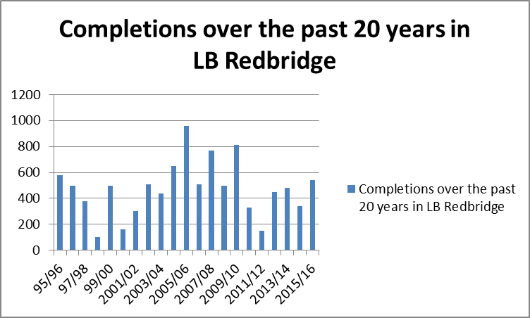

- https://www.leaguewebsite.co.uk/eleleague/LeagueHistory

FOR MORE INFORMATION PLEASE CONTACT:

Alice Roberts, Head of Green Space Campaigns, CPRE London on 07792 942 691

Or

Neil Sinden, Director, CPRE London on 07496 805 354

