London Borough of Croydon
By email to ldf@croydon.gov.uk
19 December 2019

Dear Sirs,

Croydon Local Plan Review Consultation

CPRE London is a membership based campaigning charity concerned with protecting and enhancing London’s Green Belt, Metropolitan Open Land, parks, green spaces and green infrastructure, and achieving compact, green urban communities to help prevent sprawl into the countryside.

Thank you for the opportunity to respond to this important consultation.

Green Belt release for ‘supporting infrastructure’ is NOT supported – this puts the infrastructure in the wrong place and the council has not demonstrated that exceptional circumstances exist to justify this policy.
We strongly oppose the release of Green Belt for ‘infrastructure’ which clearly should be located alongside, within or as part of new developments.

Sanderstead Recreation Ground. We do not support the expansion of a school into the recreation ground. Space can be found within existing schools or in more sustainable locations near to new development.

We do not support Option 3 which seeks to allocate Green Belt for development:
- The three sites proposed for housing under this option all make an important contribution to the Metropolitan Green Belt and as noted the release of these sites would harm the Green Belt. The Boroughs’ review concluded that all Green Belt and Metropolitan Open Land sites in Croydon do fulfil their function with only one instance of function designation not being fulfilled (a site which has already been developed).
- There are alternative sites to allocate for housing as set out in Options 1 and 2 and these should be developed first as per NPFF policy and exceptional circumstances cannot be said to exist to justify release of these sites for housing. In any event the Secretary of State has clarified that housing need is not in itself a legitimate justification for exceptional circumstances.
- Ensuring new homes are not dependent on cars must be a priority for the borough given the Mayor’s Transport Strategy targets to reduce car trips. But the three Green Belt sites identified are in locations where new residents will be dependent on cars or those without cars will have limited travel options. Notwithstanding the fact that they are nearer to public transport infrastructure than some other Green Belt sites, they are still in unsustainable locations from a transport perspective.
- Contrary to the argument set out under Option 3, CPRE evidence shows that only 1 in 10 homes built in Green Belt locations are affordable (https://www.cpre.org.uk/wp-content/uploads/2019/11/Space_to_Breathe.pdf) and we disagree that it will be easier to create affordable homes on Green Belt sites. Land values will increase if sites are allocated for housing. This is clearly demonstrated by the speculative purchase of sites like those in Crews Hill in Enfield which have changes hands since the council said it was considering the site for development.
- It is in fact easier to create affordable homes within high density developments. This is because the cost of land per unit is lower and space does not need to be given to gardens or parking (or at least, not for every new dwelling).
- We disagree that it is easier to build family homes in Green Belt locations. Three and four-bedroom properties can readily be located in high density developments. See our publication Family Housing: the Power of Concentration http://www.cprelondon.org.uk/resources/item/2196-family-housing-the-power-of-concentration
- Moreover, Croydon already has a large amount of terraced and semi-detached ‘family’ housing: it does not make sense to provide more of this type of housing – rather it makes sense to offer alternative types of family housing i.e. apartments, which are less expensive and enable people to live near to amenities, and without the expense of a car. Developments should be car free and incorporate car clubs and secure cycle parking for residents.

We support Options 1 and 2: it may be necessary to find a middle ground between these two options
We very much support the creation of new neighbourhoods (under Option 2) where “A joined up, welcoming and accessible public realm is created that delivers a shift away from a car-led place towards a more pedestrian and cyclist friendly collection of neighbourhoods.” It is vital that the starting point for major developments is that they are ‘car-free’ i.e. new residents cannot have a parking permit (and parking is controlled in the vicinity). Developments should promote walking and cycling and offer a car club option for when residents need a car.

Option 2 could be achieved without extensive Master Planning, working with landowners, and can incorporate affordable and family housing. The development of the Enfield A10 retail park especially the Colosseum Retail Park site, demonstrates a new approach to development where the landowners and developers are considering neighbouring plots and creating what is close to a landowner-led masterplan, which is also something the council can effectively shape through pre-application discussions.
https://www.colosseumretailpark.co.uk/our-proposals/

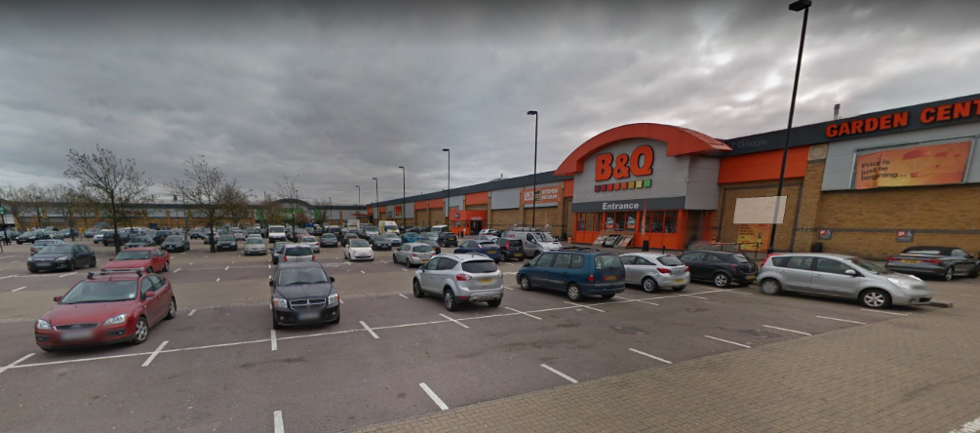
These developments can incorporate family housing as well as commercial, retail and community space.
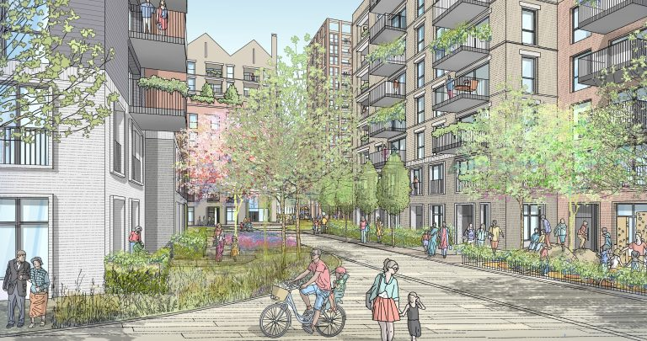
The Colosseum Retail Park, one site in the A10 retail park in Enfield – to be redeveloped as a mixed-use neighbourhood. The developers have worked on an outline Masterplan for the area to support the council in enabling neighbouring sites to be developed as well, and to ensure that sites can be developed at different times but without a ‘piecemeal’ approach.

Other sites which could be used for mixed-use developments:
- The Tesco site at Purely Cross is a 2 hectare site which could accommodate 400 to 600 new residential dwellings as well as additional commercial space if built higher (to a reasonable height)
- Surface car park adjacent to Reedham Station could be developed
- Better use could be made of local industrial sites (LSIS) where these can be intensified for mixed-use (e.g. Norbury Trading Estate etc)
- Sainsburys and surface car park at Selhurst Park stadium could be intensified for mixed-use development

Housing targets must be realistic: the proposed target is exceptionally high

The borough will have to maintain an exceptionally high completions rate over 20 years to meet the proposed target. While the borough has maintained an exceptionally high level of house building completions over the past 5 years, average completions over ten years are low when compared to the annualised target for the plan period.

Croydon should adopt a lower and more realistic, but still ambitious target. Unrealistic targets mean that too many sites are allocated, green sites are built out before brownfield sites, and land is wasted.
- Where green sites are included, developers tend to pick these first, with brownfield options going to waste. This contradicts the purpose of protections i.e. to promote re-use of urban land and avoidance of urban sprawl.
- Land is allocated for housebuilding which will not be used and so is unavailable for other useful purposes for the entirety of the plan period.

CROYDON – housebuilding targets and completions
London Plan (2016) Housing Targets | 14,348 | (annualised) 1,435
New draft London Plan targets (2018/19-2028/29) | 29,490 | (annualised) 2,949
Proposed Local Plan target (20yrs 2019-2039)  Minus the 5,370 under construction … | 46,040  40,680 | (annualised) 2,558  (annualised) 2,034
Average completions over past 10 years |  | 1,438
Average completions over past 5 years |  | 2,020
Average completions over past 3 years |  | 2,583

Thank you once again for the opportunity to respond to this important consultation.

Yours sincerely
Alice Roberts
Head of Green Space Campaigns
CPRE London

